ECE352: Signals and Systems II – Winter 2015
LAB ASSIGNMENTS AND INSTRUCTIONS
The laboratory component of ECE352 involves 5 lab assignments, each of two weeks (3 lab sessions) duration. The lab assignments apply time-domain and transform-domain concepts, learned in both ECE351 and 352, as well as extending the concepts beyond that covered in the textbook. (DO NOT take the lab component kits or removed them from the lab room).

1. Lab Location and Times

Location: Dearborn 203

Time:
Tue: 10:00AM - 11:50AM (Xin)
Tue: 12:00PM - 1:50PM (Dyuti)
Tue: 2:00PM - 3:50PM (Juan)
Wed: 10:00AM - 11:50AM (Anh)
Wed: 1:00PM - 2:50PM (Revathy)
Thu: 1:00PM - 2:50PM (Yao)
Thu: 3:00PM - 4:50PM (Juan)
Fri: 12:00PM - 1:50PM (Anh)

2. Lab Policies

The following lab policies are applicable:
- ♦ Students will work only in pairs at a lab station. No groups larger than 2 will be permitted. Students may select their lab partner, or the lab TA will select pairings.
- ♦ Lab partners will share the data sets acquired at their lab station, and may also share Matlab source code developed for processing data sets that they acquire. Data and Matlab code, however, may not be shared in common with other lab groups. This is to ensure that students fully participate in all the lab tasks, dividing the effort only with their lab partner.
- ♦ Matlab only will be used to process acquired data and to produce graphics and script source listings that will be incorporated (by importing) into the lab e-reports.
- ♦ Only Windows-based PCs are officially supported, which means that MS Word (with built-in math/equation typesetting) and MS PowerPoint (for creating drawings to be imported into Word) are the only e-document preparation applications officially acceptable for creating the lab e-reports. Submitted lab reports will be in **.doc format or converted into **.pdf format (button within Word enables this conversion). Students may use Linux-based PCs with OpenOffice Write/Draw/Math so long as the final e-report product is in **.doc or **.pdf format; however, this environment will not be supported by the TAs if you have problems creating e-documents.
- ♦ All labs, except Lab 1, have pre-lab tasks that are checked, at the beginning of the first lab session for each lab assignment, by the TA for a grade. Pre-lab tasks are expected to be completed before arriving at the lab, and shall not be started during a lab session. Pre-lab task assignments will normally be handwritten, as they are not intended for turn-in.
♦ Please submit electronic copy of your reports (required) using TEACH page (link: https://secure.engr.oregonstate.edu:8000/teach.php?type=want_auth, log in using your ENGR username, then click Submit Assignment, choose your session and upload your reports). The file name should be in the following form: YourName_YourStudentID_LabNumber_LabSessionNumber, e.g. YourName_123456789_Lab1_LabSession7. Reports are due at the beginning of the session in the week following the last lab session. Please submit a hard-copy of your reports if you can (this is optional). The TAs will collect the hard-copy reports during the lab.
- ♦ Your lab report is to be prepared only by you, that is, no joint collaborations or write-ups.

3. Lab Summaries

- ♦ Lab 1 – Data Acquisition, Import, and Export (1st and 2nd weeks)

You will learn the processes for a PC to acquire lab oscilloscope waveform data, digitized stereo audio signals from a dual microphone assembly, and digital images from a small TekBot camera into disk files. You will then learn the steps to import these acquired data sources into the Matlab environment, where the data can be processed, analyzed, and turned into graphical results. Finally, the steps to import Matlab graphics and script listings into the Word document-preparation software will be exercised.

- ♦ Lab 2 – Image Spatial Analysis (3rd and 4th weeks)

You will use the TekBot camera to acquire special imagery that will illustrate principles of spatial frequency analysis. You will then learn the process of deconvolution (convolution in reverse!) to deblur an image blurred by translational motion. Finally, you will use time and frequency domain methods to find an audio authentication hidden within an image by a process called digital watermarking.

- ♦ Lab 3 – Analog Filters: Temporal and Frequency Circuit Analysis (5th and 6th weeks)

You will build second-order low-pass and high-pass filter circuits from R and C elements, and then you will measure the circuit frequency response and step response for comparison with the theoretical responses. Those measurements will then be used to predict the response of the circuits to two periodic waveforms.
- ♦ Lab 4 – Acoustic Direction Finding (7th and 8th weeks)

You will experiment with the dual microphone assembly to perform an experiment which will locate in space (by range and bearing angle) an acoustic signal source. Using a cross correlation technique (a variation of the convolution operation), you will estimate two time differences of arrival between the two spatially separated microphones, and from these you will pinpoint the location of the acoustic source by triangulation principles.
- ♦ Lab 5 – Digital Filters: The Hunt for Red Herring (9th and 10th weeks)

You will apply digital filter and communication demodulation techniques to extract multiple voice messages in a communication waveform created by frequency division multiplexing (FDM). One of those messages is from a spy agent called Red Herring!

4. Lab Report Format and Preparation Requirements
Your lab report will be prepared as a single integrated document using Microsoft Word Figures will be imported into your Word documents from PowerPoint and/or Matlab. Typically, any drawing you create in PowerPoint can be simply cut from PowerPoint and pasted into Word. Figure windows created by Matlab, initially exported from Matlab and saved as typically **.tif or **.jpg files (other file extensions also are possible, but these two formats seem to preserve best the figure fidelity), can also be imported into your Word report document using Insert -> Picture -> From File pull-down menu selections. Your lab TA can assist you with demonstrations of these steps. Matlab script files can similarly be imported directly into Word as **.m text files using the pull-down menu selections Insert -> Text -> From File, in order to create embedded source code listings.
A lab report will typically be 5 to 15 pages (not including Matlab script listings), determined by the complexity of the lab assignment and the number and sizing of imported figures. Your lab report should contain answers to all questions posed in each lab assignment and have final equation results for lab tasks that require such development (the step-by-step equation detail is normally covered in the handwritten pre-task effort examined by the TAs, so the step-by-step detail does not need to be typeset into the submitted lab report). Each figure should be numbered, have horizontal and vertical axes labeled with units, and a caption provided. An exemplar report is being generated by one of the course TAs, and will be shown during the first two lab sessions.
The format for the lab report should have the following components and section numbers:
- ♦ Cover page (use template coverpage.doc on the course web site, and make changes on this template as appropriate for each lab report)
- ♦ 1. Introduction.
- ♦ 2. Math analysis by task (if required by task narrative or to support your lab results).
- ♦ 3. Experiment notes by task (observations; issues; details of methodologies used during the lab experiments; answers to task questions posed in the lab assignments).
- ♦ 4. Results by task (bulk of report; contains most of the imported figures; answers to task questions if not provided in prior sections; other measurement and result details not covered in the other sections).
- ♦ Appendices: listing of all Matlab scripts developed specifically for a lab assignment; use one appendix per script. Sequence the appendices as A, B, C, etc.

- 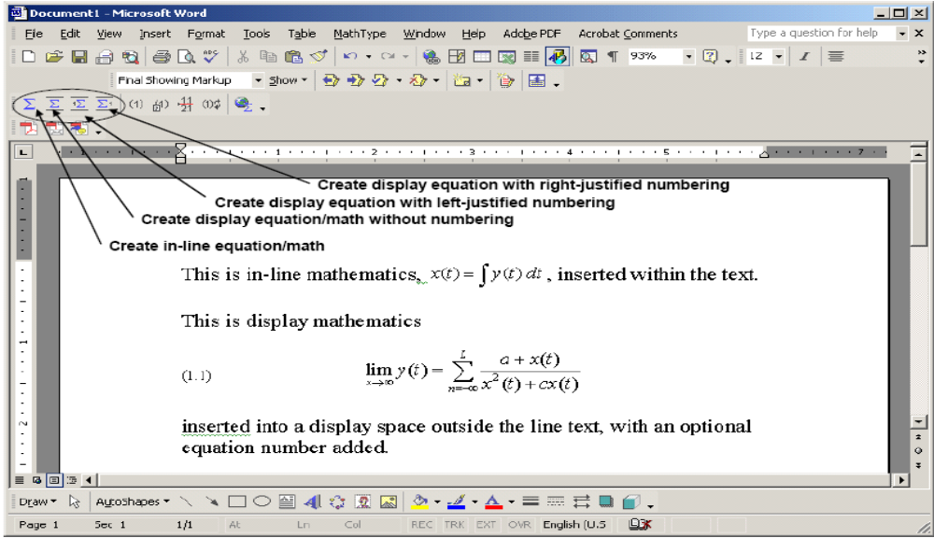

To typeset math and equations in your Word document, all OSU engineering lab PCs with Word have a built-in math typesetter based on an application called MathType. It is activated by selecting one of four Word toolbar buttons with a summation symbol, as shown in the figure on the previous page. Once a summation button is activated, a new math typesetting window appears, as shown below:

- 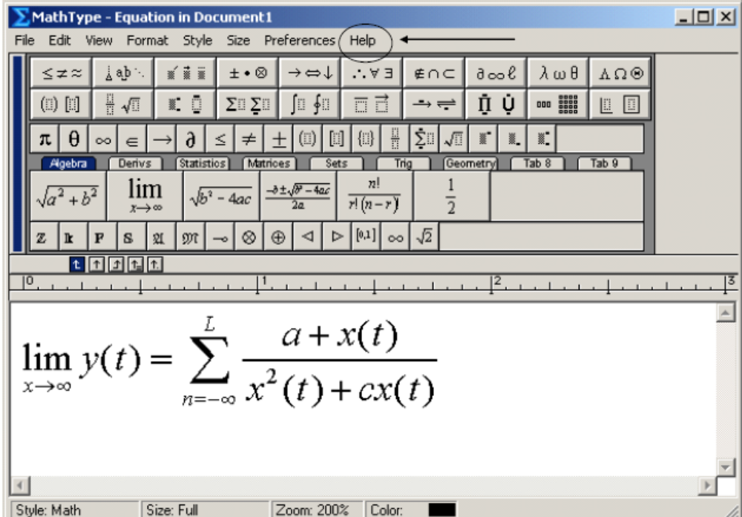

Tutorial details for inputting math and equations is covered nicely in the HELP pull-down menu, indicated by the arrow at the location shown in the above figure.

5. Lab Report Submission Procedure and Grading

All lab reports must be submitted to the TA in charge of your lab session by the time specified in Section 2. The lab TAs will return back your cover page. They will handwrite your lab grade and any comments they have about your report on this cover page. This graded cover page will then be provided back to you in a sequel lab session as a formal hardcopy of your graded report. Each lab is worth 5 points, with typically 1 point awarded for timely submission of the pre-lab tasks (exception: lab 1, which has no pre-lab task).

